# Oxygen therapy and Continuous Positive Airway Pressure (CPAP) in adults

## *Executive summary*

## Introduction

Oxygen therapy is a medical treatment that when used appropriately can be life-saving. CPAP is a form of non-invasive ventilatory support for patients who are breathing spontaneously. A continuous oxygen and air mix is delivered under pressure to the patient via a mask, helmet or nasal prongs. CPAP can help maintain clear airways, improve gas exchange, improve lung volume and reduce the work of breathing. It is primarily of use in non-hypercapnic respiratory failure (Type 1).

## Target User

* Doctors
* Nurses

## Target area of use

* COVID isolation ward or Negative Pressure side rooms (when used for COVID-19 related hypoxia)
* General wards (when used for acute cardiogenic pulmonary oedema)

## Key areas of focus / New additions / Changes

Indications, complications and how to use CPAP.

## Limitations

In many settings CPAP is provided as part of a range of ventilator support options including Bi-level Positive Airway Pressure (BiPAP) and full ventilator support with intubation. These options are not currently available at MRCG-CSD but may be available at EFSTH or the Sanatorium. Should a patient not improve on CPAP, consideration of transfer should be offered. If this is not appropriate or possible, then consideration of how to palliate them best must take place.

## Oxygen therapy

Oxygen use is a medical treatment with benefits and complications. On initiation of oxygen therapy, it is important to consider the oxygen demands of the patient and the oxygen saturations required. This will direct which device and flow rate from the cylinder of concentrator is commenced. As with any therapy, careful assessment of response is necessary. With oxygen therapy, the response should be almost immediate with a change in oxygen saturations. It is advisable to stay with your patient until the oxygen saturations you desire are reached or, if necessary, escalation of support is initiated.

Positioning of your patient to improve lung recruitment and ventilation perfusion matching can be utilized at any point in the oxygen escalation pathway and may even improve the patient’s condition so that the next level is unnecessary.

The positions on the next page can be tried with or without CPAP. The flowchart on the following page guides oxygen delivery.

For patients deteriorating on the ward, escalation of oxygen therapies should be considered prior to commencing CPAP. These options should be tried sequentially:

* Nasal cannula ≦ 6 L/min
* Hudson mask at 10 L/min
* Venturi mask if available (start with 50% and increase to 60% if not responsive)
* Non-rebreather mask at 12-15 L/min
* Consideration for CPAP

## Oxygenation in an emergency admission:

## Indications and Contraindications for CPAP:

### Indications:

CPAP is useful in certain conditions causing Type 1 respiratory failure:

* Acute cardiogenic pulmonary oedema
* COVID 19 with worsening oxygenation despite optimisation with oxygen therapy and other inputs.

CPAP is less likely to be useful in other conditions causing Type 1 respiratory failure including:

* Pneumonia
* Respiratory infection in the immunocompromised
* Asthma

In these patients CPAP may be considered though should be close review over the 2 hours following initiation and attention paid to the possibility of complications (eg. pneumothorax or hypotension which may be more common in this subgroup).

*CPAP is not indicated in type 2 respiratory failure.*

### Contra-indications:

* Respiratory arrest
* Un-cooperative patient
* Unable to protect own airway or upper airway obstruction
* Oral/facial abnormality or injury meaning a good seal cannot be achieved
* Known pneumothorax (unless this has been treated with a functioning tube thoracostomy)
* Patients with underlying condition in whom CPAP is unlikely to make an improvement

## Considerations

Before starting CPAP, the patient should be fully assessed by the doctor. All cases starting CPAP should be discussed with the consultant on call.

It is important to ensure that there will be sufficient oxygen for the procedure, stocks should be checked before CPAP is started.

CPAP is considered an aerosol generating procedure and attention should be paid to where it is performed (ideally in cohort or individual isolation if respiratory pathogens may be present).

The doctor should:

* Review the patient and consider other causes of deterioration (e.g bacterial superinfection)
* Check or order a recent chest X-ray to ensure there is no pneumothorax
* Review the patient’s treatment escalation plan before starting CPAP.
* Discuss with the patient what CPAP will involve (shaving, wearing a tight-fitting mask that will generate pressure on their face, claustrophobia) but also point out that it may help with their breathing and make them feel better.
* Target saturations should be set for all patients when CPAP commenced. Usual target saturations would be 90-94% for those without pre-existing lung disease or 88-90% for those with a significant history of COPD.
* Some patients may need small doses of anxiolytic medication/sedative (eg 1-2mg diazepam or 1-2.5mg oromorph) to enable them to tolerate the mask.

## Fixation Technique

This will depend on the device available. See separate guidance.

A good seal is likely to require shaving of facial hair and electric clippers and razors will be needed to achieve this.

## Starting CPAP in a deteriorating ward patient:

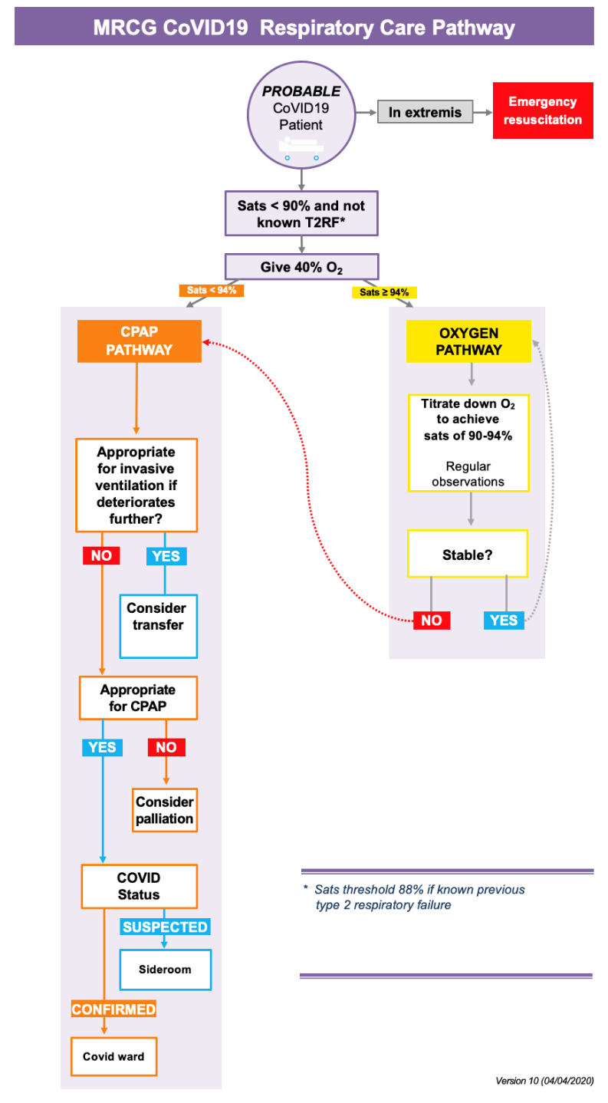

## Monitoring and Adjustments

The CPAP can be adjusted to provide variable end expiratory pressures, the range depending on the device. In general, pressures below 5cm H2O and above 15 cm H2O are not usually required.

Where possible end expiratory pressure should be built up slowly, over approximately 10 - 15 minutes from 5cm H2O to a target pressure of 10cm H2O in 2.5cm H2O increments. Recheck BP and pulse after pressure is increased.

Settings should be adjusted according to the observations of the patient, including saturations, as well as the clinical assessment.

The entrained oxygen concentration (FiO2) can be varied depending on the device and this should be adjusted to the minimum required to achieve the target saturations (aim for the lower end of the target saturations provided respiratory rate and work of breathing are OK).

Signs of deterioration:

* Increased Respiratory Rate (>30 breaths per minute or increase >10 breaths from baseline)
* Increased Heart Rate ( >20% or 20 bpm from baseline)
* Hyper- or hypotension (increase/decrease of 20mmHg from baseline)
* Persisting drop in SpO2 below target
* Increased work of breathing
* Patient reports breathing difficulty
* Patient requesting increase FiO2/pressure/replace mask
* Patient has difficulty speaking

Actions if deterioration:

* Check for leak
* Is the tubing correctly set up?
* Are the settings set up correctly?
* Are secretions an issue
* Check filter – is it wet or are the visible secretion? If so, consider changing.
* If the patient is on a CPAP break, restart CPAP
* If patient has been weaned then revert to previous settings
* Re-examine for signs of complications (eg bacterial super-infection, pneumothorax etc)
* Consider symptom control medications

If patient deteriorating despite the above consider either transfer or palliation. For palliation, then may remove the mask and using symptom control medications. Consider if relatives should be informed.

## Continuation and weaning CPAP for COVID-19

* In the first 48 hours, aim to use CPAP as much as possible with CPAP ≥ 10cm H2O and sats 90-94% (88-90% if significant COPD)
* Breaks will be required during which patients should be given nasal prong oxygen at 4L/min or high flow O2 with a non-rebreather to maintain saturations
* Breaks should be approximately every 4 hours and should be planned with CPAP decreased slowly to 5cm H2O for 10 minutes prior to the break. During CPAP breaks, ensure patient offered food and drink.
* Wean oxygen prior to CPAP until FiO2 <35%
* CPAP should be weaned in steps of 2-3cm H2O if possible, with a maximum of 5cm/24 hours
* Ideally hold at 5cm H2O for 24 hours prior to discontinuing CPAP
* When disconnecting CPAP ensure that the flow is turned off before the mask is taken off the face (to limit aerosolisation). Ensure that an alternative oxygen supply for the patient (eg nasal prongs) is prepared to avoid desaturation.
* Ensure accurate documentation of time on/off CPAP and pressures used.

## Feeding

Feeding and adequate hydration while patients are on CPAP is vital. With the mask this is difficult. Ideally patients should have a period of at least 4 hours on the mask to improve their respiratory status to start with before taking it off. IV fluid should be considered. After this, short pauses to allow food and fluid are acceptable.

## Complications

### Clinical:

* Inadequate ventilation
* Overventilation
* Pneumothorax
* Decreased cardiac output due to increased intrathoracic pressure
* Gastric distension
* Mucus plugging/buildup of secretions
* Oral/nasal/eye irritation
* Pressure areas from tubing or straps
* Aspiration

### Mechanical:

* Mechanical failure of ventilation delivery due to flow rate being too low
* Interface damage, leak, dislodgement or misfit
* Circuit leak and damage

If a patient is deteriorating or not managing on the mask, CPAP may need to be removed. Review the patient and have a conversation with them. CPAP is not pleasant to wear. If the patient chooses to have it off, make it clear that they can change their mind again. If the patient is deteriorating and dying, then consider removing the CPAP mask and using symptom control to manage their breathlessness rather than continuing with CPAP.

## Key Issues for Nursing care

* Patients on CPAP should be closely monitored with 2 hourly observations as a minimum with checks of all routine vital observations (oxygen saturations, pulse, BP, conscious level, temperature, respiratory rate) and the circuit, oxygen flow and remaining in the tank, leakage, pressure areas, humidification, filter.
* Mouth care should be carried out every 4 hours, patient offered sips of water.
* Strict fluid balance chart must be maintained and the doctor called if the urine output drops below 0.5 ml/kg/hour for more than 3 hours
* All equipment will be decontaminated between each patient and any single use items should be disposed of.
* CPAP is an aerosol generating procedure and full PPE must be worn when attending to patients with respiratory pathogens (eg patients with COVID-19)

## References

UCLH COVID-19 guidance (30 April Version, available through AppStore/PlayStore, accessed 30 May 2020)

<http://go.gomango.co.uk/diamedica.co.uk/english/weblive_documents/BabyCPAPmanualEnglish.pdf>

|  |  |  |
| --- | --- | --- |
| **Written by:** | Name: Behzad Nadjm | Date: 10 August 2020 |
| **Reviewed by:** | Name: Ana Bonell | Date: 14 October 2020 |
| **Version:** | **Change history:** | **Review due date:** |
| 1.0 | New document | 14 October 2022 |
| Review Comments (*if applicable)* |  |  |